Analyzing Categorical Data

Analyzing One categorical value

V: Identifying individuals, variables and categorical variables in a data set
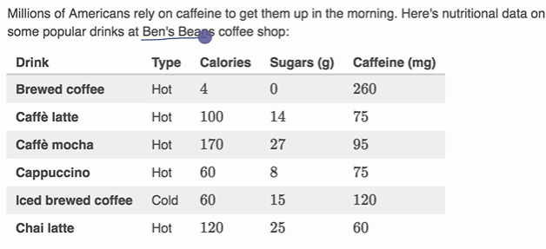
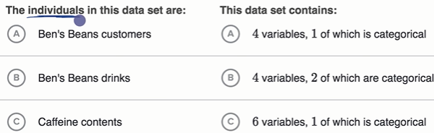
Here type is categorical data, it can be placed in one bucket that is either hot or cold.

Reading Pictographs
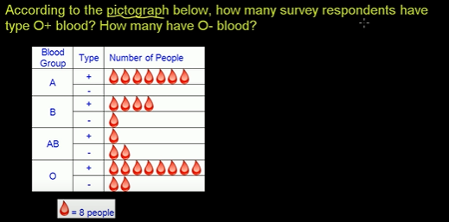

Ans:64

Reading bar graphs
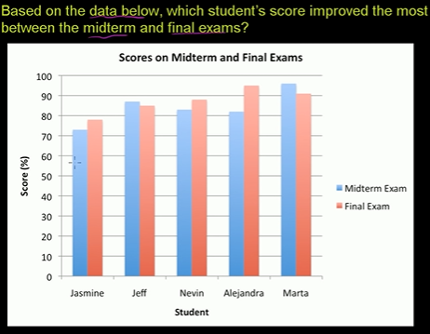

Reading bar charts: putting it together with central tendency
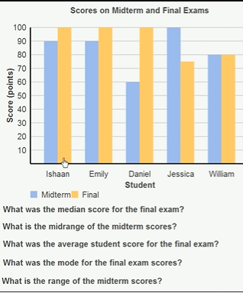


Median:

Midrange as the arithmetic mean or average of the highest and lowest score.
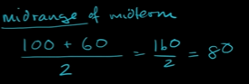

Average is mean
Mode is the most frequent ans
Range is 100-60=40

Reading pie graph
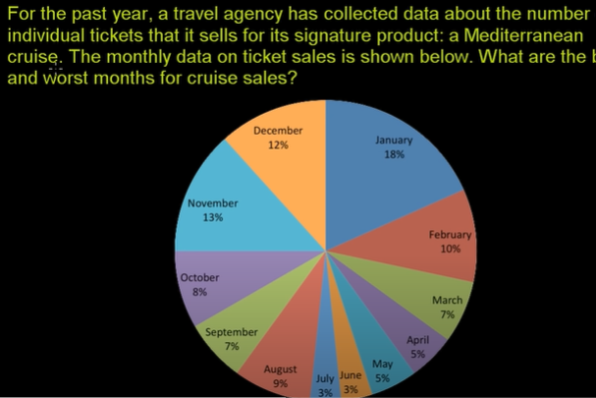

Two way tables

Two way frequency table and venn diagrams
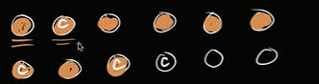

Only brown is just chocolate.
brown+c is chocolate with coconut in the inside
Empty is neither chocolate or coconut
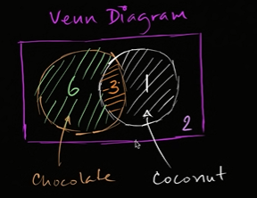
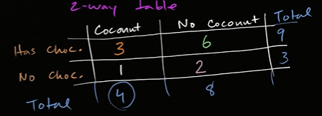

Two way relative frequency table
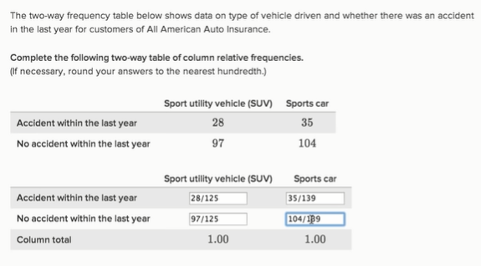
You can also say after doing calc , for an SUV 22% of vechile had accident.

Interpreting two-way tables
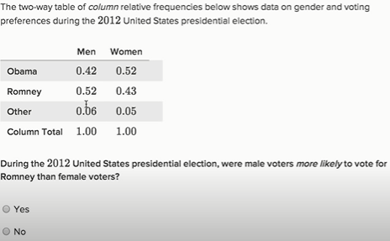

→ Yes

Categorical Data example
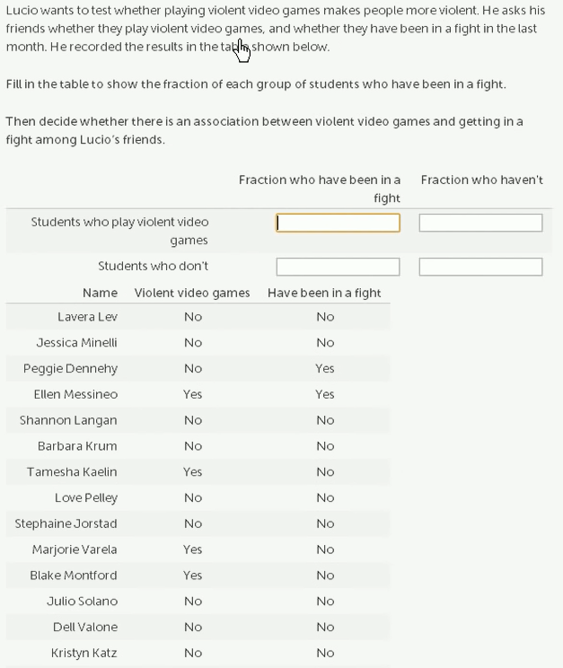

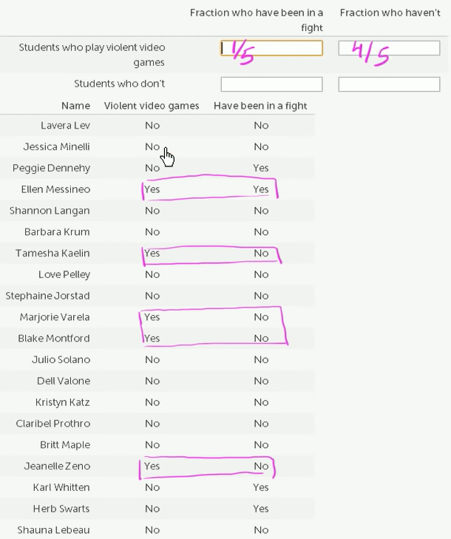
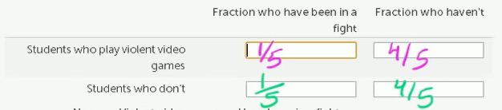
This is a way to find association between students who play violent video games and get into fights. From the data, there is no relation of games to fights

Analyzing trends in categorical data
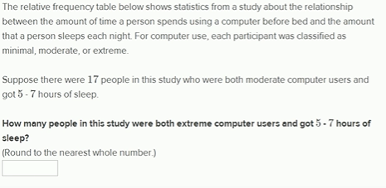

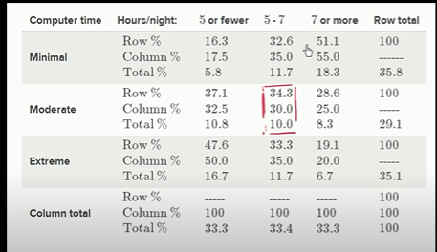

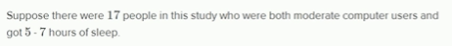
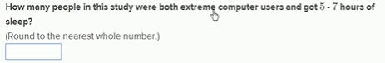

Above , 17 ppl or 34.3% are the moderate user who had 5-7 hrs sleep
Or you can say 17ppl or 30.0% are the 5-7 hrs sleepy people .
Or you can say 17ppl is the 10.0% of total no of moderate user ppl.
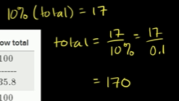

So no of ppl who are extreme user who had 5-7hr sleep is
11.7%*170
=19.89
=20ppl

Here,
Column% value
for e.g 35% represent minimal user ppl who have 5-7hr sleep
for e.g 30% represent moderate user ppl who have 5-7hr sleep
for e.g 35% represent extreme user ppl who have 5-7hr sleep
Which in total is 100% of ppl who have 5-7hr sleep.
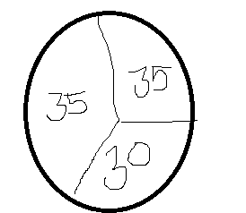

Row%value
for e.g 16.3% under (5 or fewer) for minimal represents the percentage of minimal users who had (<=5hr sleep)

The total for each unit represent the no of ppl that fall under that category/no of ppl who were in test.
33% ppl were in <=5 , 34% ppl were in 5-7, 33% ppl were in 7 or above

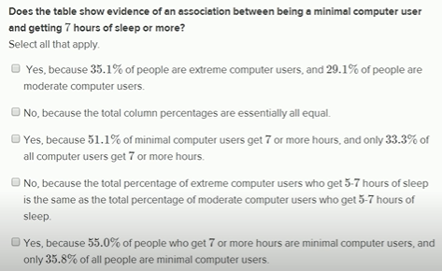

So you can say 51% of minimal computer user get 7 or more hour sleep.
Or
You can say 55% of 7 or more hour sleepy person are minimal computer user.
18.3% is the highest percentage of 7hr sleepy person who are also minimal user.
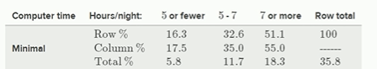

You can see the distribution is weighed more towards more sleep.
For Exteme computer user is the opposite trend
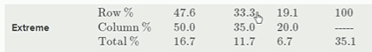

So you can say if u use computer less u r more likely to have more sleep.
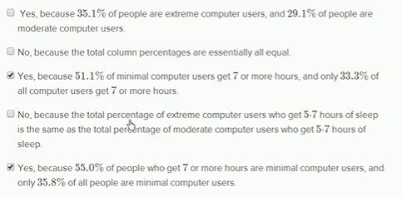

Distribution in two way tables

Marginal and conditional distribution
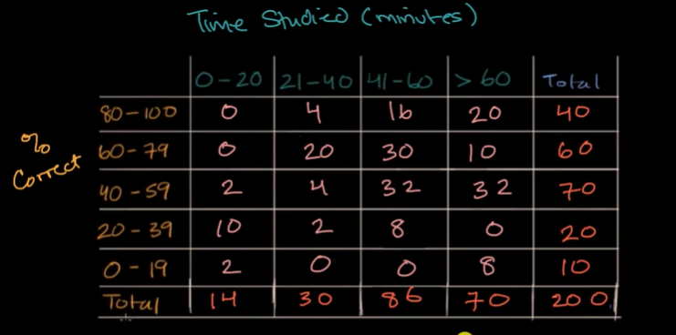
In a classroom of 200 students.
Here, we trying to understand the relationship between the amount of time studied and the %Correct.
We have created buckets, we take a survey and look on the score of the test and then we place student in these buckets
This is a two way table or joint distribution along this 2D
Other types of distribution are:
Marginal distribution: is a distribution focusin on one of these dimensions. One way of looking about this is u can determine it by looking at the margin.
So to find marginal distribution of the %correct, u look at total of the rows

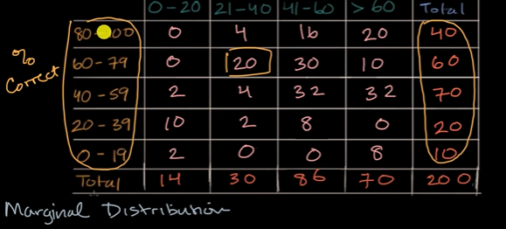
Marginal distribution can be reprsented as count or as percentages.
40 out of 200 got between 80-100 correct ans
60 out of 200 got between 60-79
Similarly, u can apply this to time studied.
Say 14/200 studied for 0-20 hrs.
Another way that ppl use to get more info out of it.
Conditional distribution: This is the distribution of one variable given something true about the other variable.

Standard practice for conditional distribution is to think with percentages
